# Linux encode

## Set encode to utf-8

Configuration of encode stores in /etc./sysconfig/i18n, so open this file to edit encode. 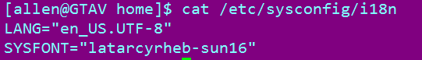

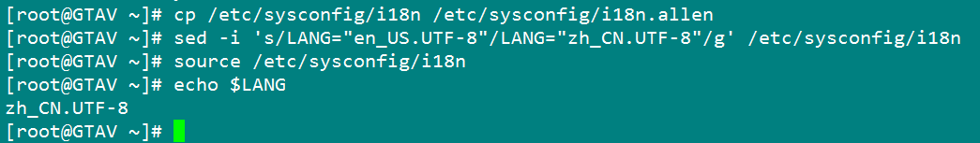

First, need a backup; then, exchange the encode to your encode, and use “source” command to make it alive;

## Source command

Source filename: execute commands from filename in the current shell, so it means the “filename” will be initialized again. You could use “. Filename” that is same function as “source filename”. 

This command is a built-in command